**ODD OR EVEN**  
  
**AIM:**To write an assembly language program to implement odd or even using 8085 processor.  
**ALGORITHM:**  
1)   Start the program by loading a register pair with address of 1st number.  
2)   Copy the data to another register pair.  
3)    Load the second number to first register pair.  
4)    Subtract the two register pair contents.  
5)    Check for borrow.  
6)    Store the value of difference and borrow in memory locations.  
7)    End.   
**PROGRAM:**  
     LDA 2050H

ANI 01

JZ LOOP1

MVI A,11

JMP LOOP2

LOOP1: MVI A,22

LOOP2: STA 2051H

HLT  
**INPUT:**

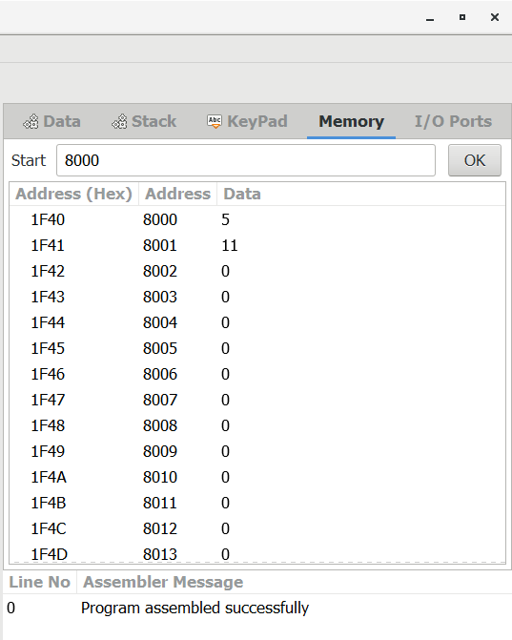

OUTPUT:

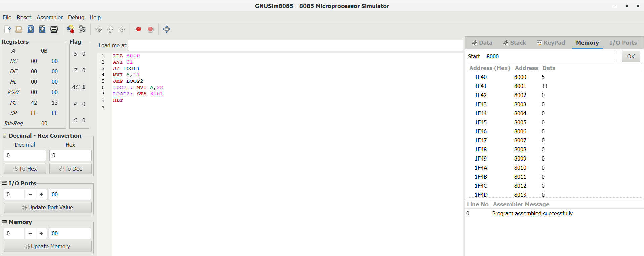

RESULT:

Thus the program was executed successfully using 8085 processor.